**Micheal Amedie**

**Capstone shiny app project**

**Introduction**

Diabetes is a chronic (long-lasting) health condition that affects how your body turns food into energy. Most of the food you eat is broken down into sugar (also called glucose) and released into your bloodstream. When your blood sugar goes up, it signals your pancreas to release insulin. Insulin acts like a key to let the blood sugar into your body’s cells for use as energy.

**Types of diabetes**

* **Type 1 Diabetes**

Type 1 diabetes is thought to be caused by an autoimmune reaction (the body attacks itself by mistake) that stops your body from making insulin. Approximately 5-10% of the people who have diabetes have type 1.

* **Type 2 Diabetes**

With type 2 diabetes, your body doesn’t use insulin well and can’t keep blood sugar at normal levels. About 90-95% of people with diabetes have type 2.

* **Gestational Diabetes**

Gestational diabetes develops in pregnant women who have never had diabetes. If you have gestational diabetes, your baby could be at higher risk for health problems.

**Scope of the study**

The scope of this study is to design a shiny app that is able to plot a graph based on the users input of variable and the variable type.

**Data source**

The data was found from <https://clinicaltrials.gov/ct2/home> . The clinical trials website is a resource provided by the us. National Library of medical. The dataset has 38 statistically significant columns and 3189 observations.

**Outputs of the App**

The app has two major category of outputs the first one which is found using the Variable study button.

These plots are sub-categorized using Study type against varies categories. There are two types of study type:

1. **Observational study** – this study is performed by the researcher without performing any action that might led to changes in the result
2. **Interventional study** – in this study the researcher performs actions that led to variation in the result.

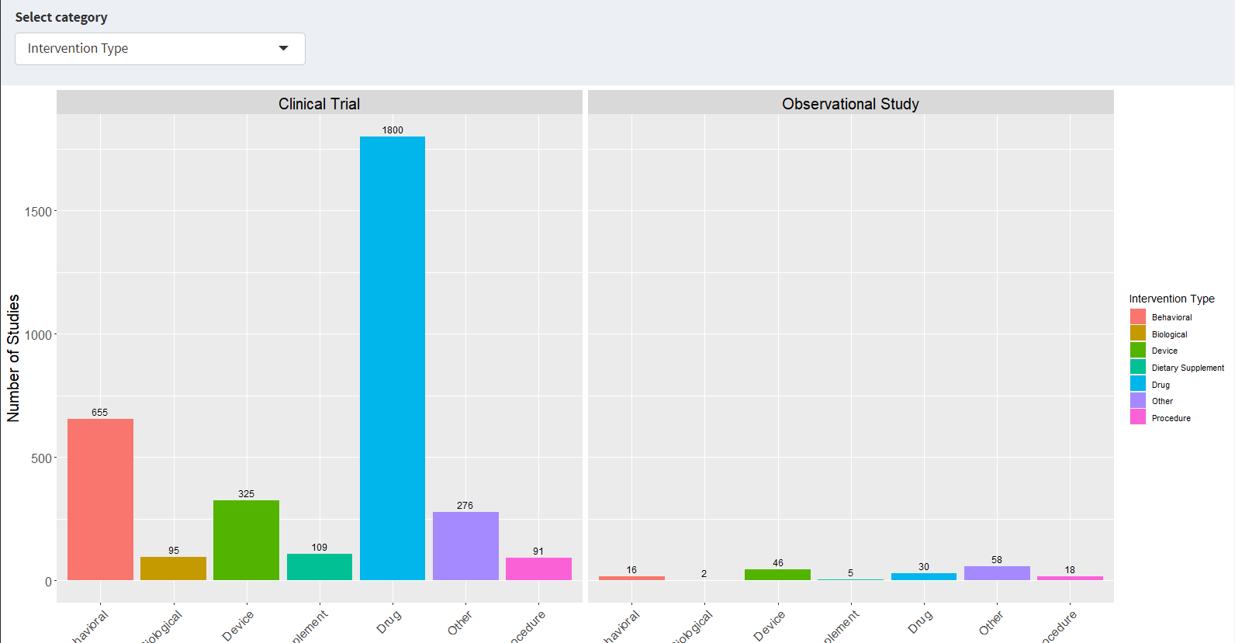

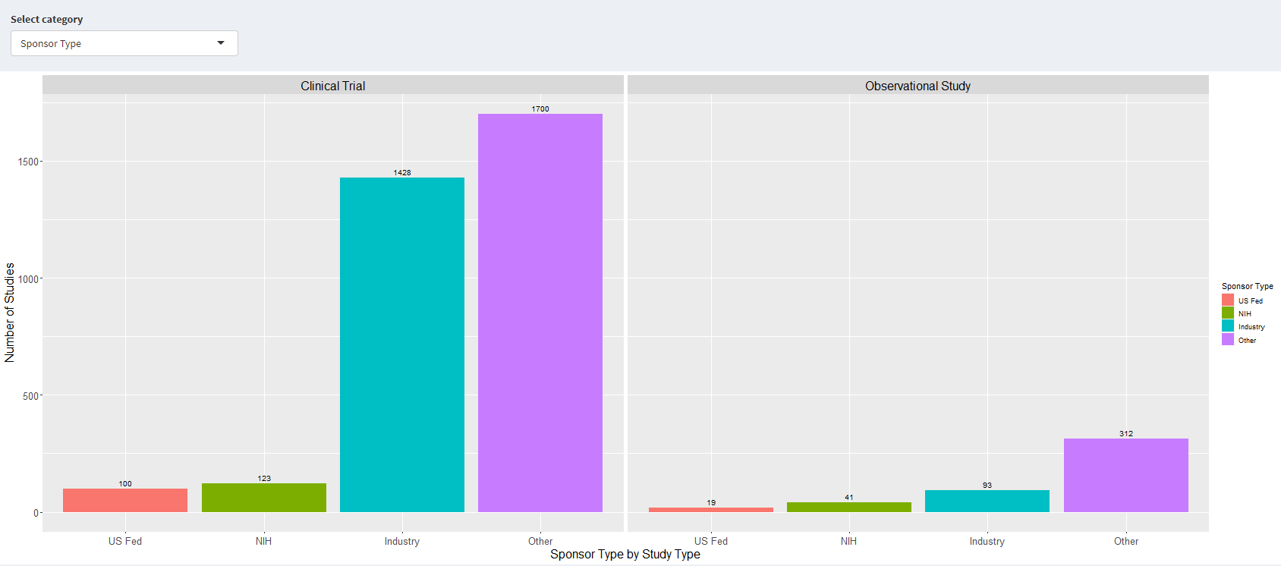

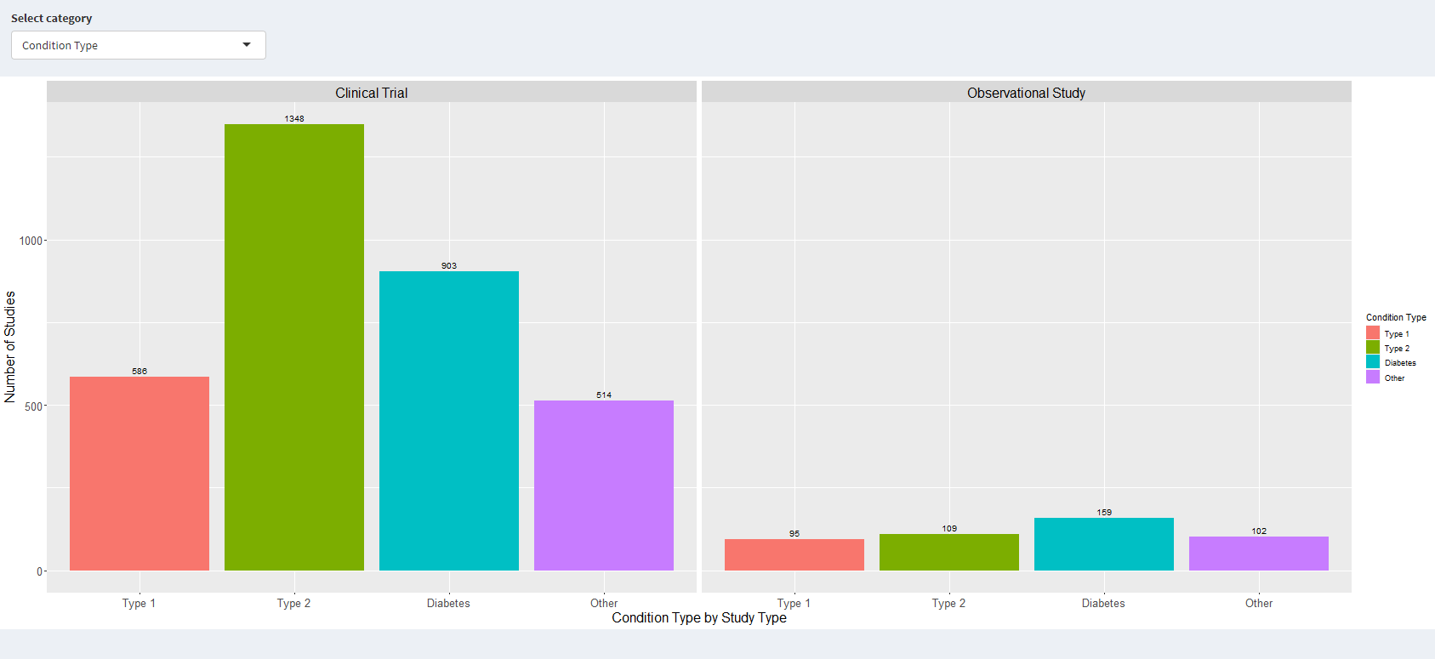

The second group of plots are found in the Data in years tab. In this section the data analyzed in accordance with the year that the type of graph selected are line graph. This graph was selected because the variables (year) is a continuous data type.

Some of the plots in this group are displayed below:

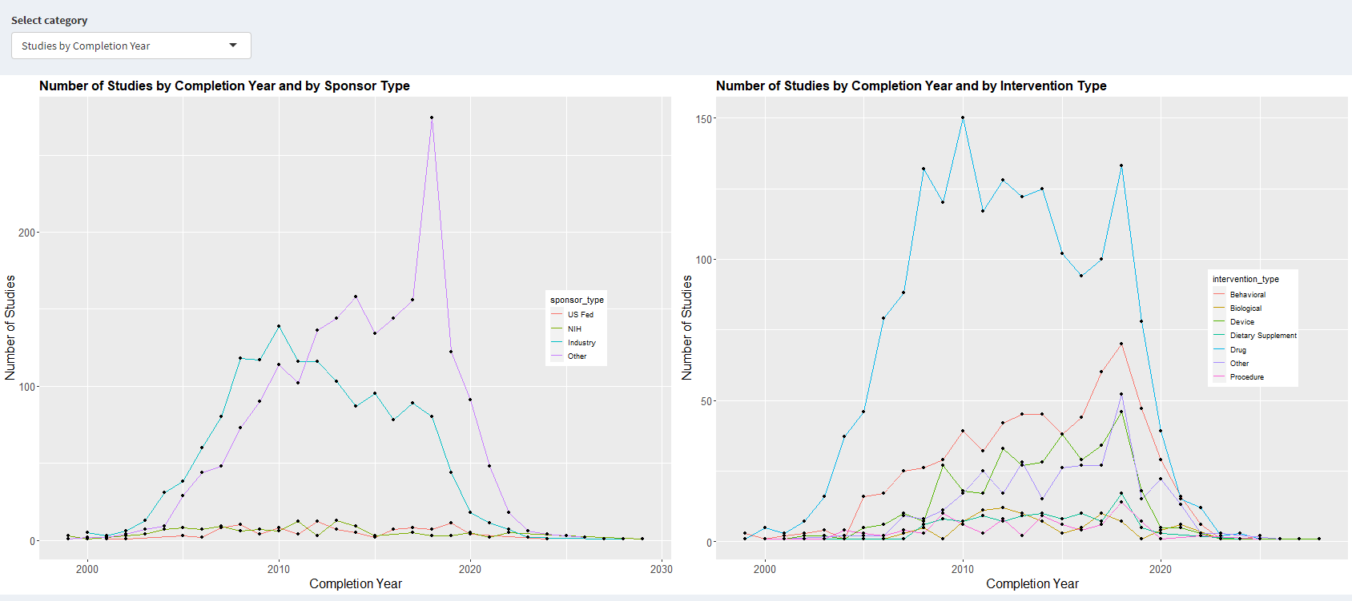

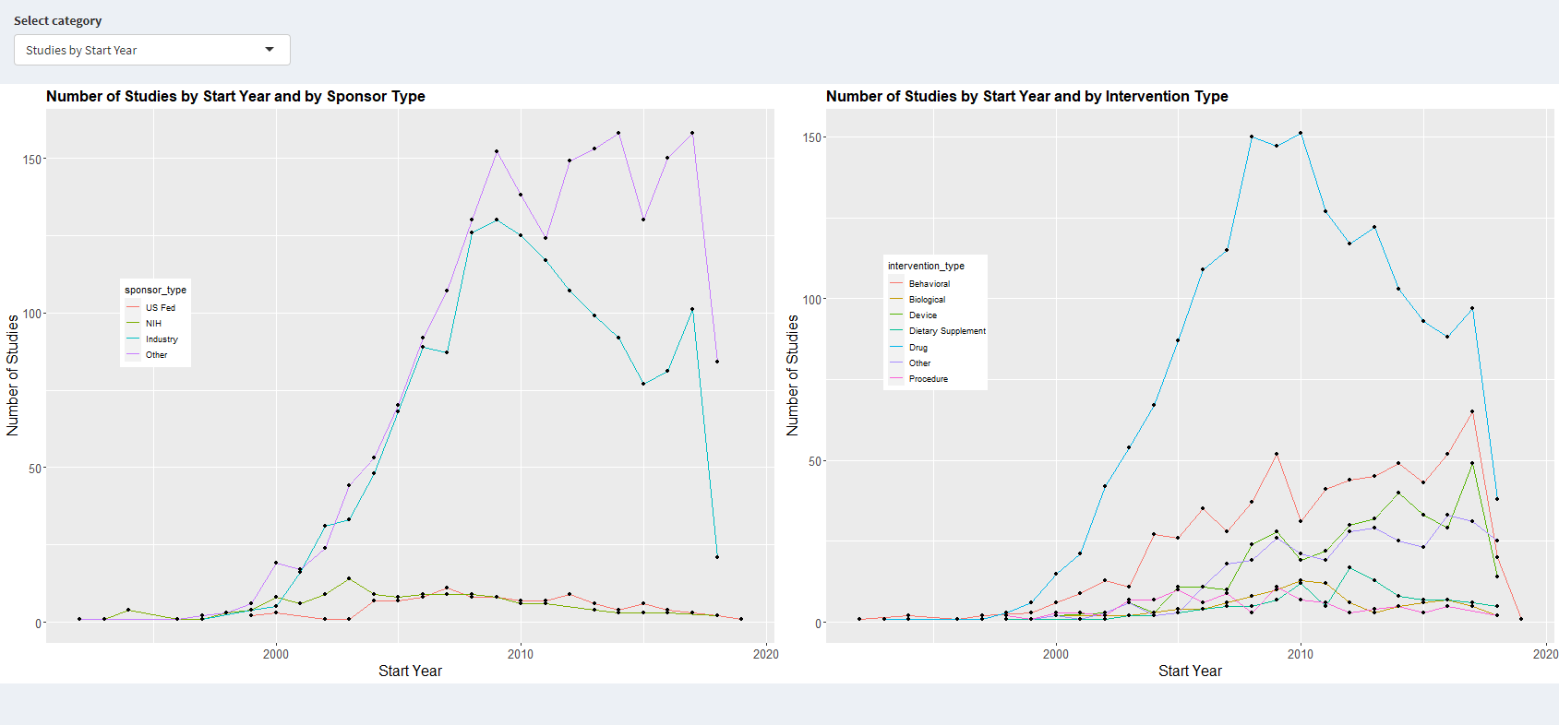

**Reference**

* <https://shiny.rstudio.com/gallery/>
* <https://clinicaltrials.gov/ct2/home>
* https://www.cdc.gov/diabetes/basics/diabetes